Campus Management Corp.

Implementation Questionnaire

May 20, 2018

# TABLE OF CONTENTS

TABLE OF CONTENTS i

[1] IDENTIFY DYNAMICS CRM ORGANIZATIONS 1

[2] SETUP SERVICE ACCOUNTS 1

[3] INSTALL PORTAL SITES 2

[4] BRAND THE STUDENT PORTAL 2

[5] UPATE THE LINK TO THE LMS SYSTEM 3

[6] SECURITY ROLE AND USER SETUP 3

[7] ASSIGN FIELD LEVEL SECURITY PROFILES (DOB/SSN) 4

[8] CUSTOM WORKFLOWS & BUSINESS RULES 4

[9] INBOUND INTEREST AUTO QUALIFY RULES 5

[10] CONTACT TYPES 6

[11] LIFECYCLE STAGES / BUSINESS PROCESS FLOW 7

[12] DUPLICATE DETECTION RULES 9

[13] REPORTS 10

[14] DEFAULT DATA 11

[15] SUBJECTS 12

[16] QUEUES & TEAMS 13

[17] CONNECTION TYPES 14

[18] INBOUND INTEREST SOURCES 15

[19] CONTACT RETENTION SCORING RULES 17

[20] SETUP SUCCESS PLAN ASSIGNMENT RULES 19

1. IDENTIFY DYNAMICS CRM ORGANIZATIONS

## Description

A Dynamics CRM Organization holds the collection of data. Data may not be seen across organizations without logging into each organization independently. Within an organization, data may be limited based on permissions. There are some settings that are global across the entire organization, so if multiple campuses share one organization, they will need to agree on some system settings.



## Client Questions

1. How many CRM environments are needed?
   1. Remember, this physically separates the data and users will have to navigate to different URLs to see data in each.
   2. Security may be managed in a single database as well, so that there is flexibility to allow certain analysis and users the ability to see data across campuses.
2. What is the name of each CRM Organization?
3. SETUP SERVICE ACCOUNTS

## Description

Service Accounts will be used for allowing automated systems to run. These accounts are not necessarily associated to a real person and should have an expiring password managed by an infrastructure global system administrator. It is possible to use one account for multiple services.

1. **PowerBI** – The PowerBI user is the user who has full control over the Retention Dashboard and who the Retention Dashboard will run as when viewed in Dynamics CRM. They must be created as a user in Office 365 with permissions to access Power BI. In Dynamics CRM, they’ll need to be given the System Administrator Security Role.
2. **CRM Service Account** – The CRM Service Account is the user who will be responsible for installing the Campus Management Solutions. They be an actual user in Office 365 and must be given the System Administrator security role in Dynamics CRM.
3. **Azure Function** – The Azure Function User is the user who automated Azure Functions will run as when accessing Dynamics CRM.  They should be created in Dynamic CRM only as an Application User and given the CMC – Azure FunctionApp and System Administrator Security Roles.



## Client Question

What are the domain user names for the following users?

1. PowerBI
2. CRM Service Account
3. Azure Function
4. INSTALL PORTAL SITES

## Description

The Portal sites provide a way for Students who do not have access to Dynamics CRM to interact with data inside Dynamics CRM. The Portals are accessed through a separate website and login from Dynamics CRM. They also have their own security model.

Two Portals currently exist

1. **Student** – A customized Portal that provides access to select data in the Campus Management solution.
2. **Marketing** –Thedefault Portal installed with the Marketing Solution. This is currently required to be setup when installing the Dynamics 365 for Marketing Solution.

Portal Users are created as Contacts in Dynamics CRM. Please see the Deployment Notes for how to tie a Contact record to a user in Azure Active Directory. When creating the Portal User record, make sure to give them a Web Role of Students so they can properly access the Student Portal.



## Client Question

1. What URL would you like to use for the Student Portal?
2. What URL would you like to use for the Marketing Portal?
3. What authentication will you be using for the Students?
4. Which Students would you like to create Portal users for?
5. BRAND THE STUDENT PORTAL

## Description

The Student Portal is shipped in a generic state that could be used by any university. To better brand the Student Portal to a specific university, the following changes may need to be done to Portal records:

1. Change the text in the top left of all pages to the name of the university or an image.
2. Change the Bootstrap style applied to the Portal.
   1. The Bootstrap style applied to the Portal by default is the [Bootswatch Lumen](https://bootswatch.com/lumen/) theme.
   2. A custom Bootstrap style can be applied by replacing the file attached to the bootstrap.min.css Web File.
   3. Applying a custom Bootstrap theme may require manually modifying certain styles. Most changes can be made in the theme.css Web File.
3. Change the images on the home page.



## Client Question

1. What name or image should be displayed in the top left of the portal?
2. Is there a custom Bootstrap theme to apply to the Portal?
3. Is there a standard branding document and/or image files used for continuity in branding applications?
4. What image changes or other branding should be done to the portal?
5. UPATE THE LINK TO THE LMS SYSTEM

## Description

From the Campus Nexus Engage Student Portal, you can link to your institution’s LMS system. This link will be found under the Education menu once the student is logged into the Student Portal. From this link, a new browser tab will open where the Student can login to the LMS.



## Client Question

1. Do you want to include a link to your LMS system from the Student Portal?
2. What is the URL to your LMS system?
3. SECURITY ROLE AND USER SETUP

## Description

Security Roles allow different user in the organization to have different permissions to see and edit data in Dynamics CRM. A user with multiple roles will have the highest combined level of rights.

The following are the out of the box Security Roles. Login to Dynamics CRM to view the permissions of each role:

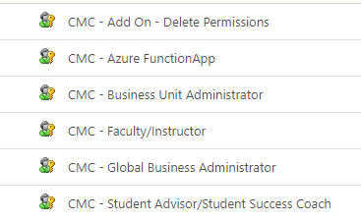



## Client Question

1. Are there any updates that need to be made to existing Security Roles?
2. Are there any new security roles needed?
3. Provide a spreadsheet of each User in the system, their email address, their domain name and which Security Role they should be assigned.
4. ASSIGN FIELD LEVEL SECURITY PROFILES (DOB/SSN)

## Description

There are certain data points that are especially private and special care is taken to control who can read and edit these fields. In Dynamics CRM, Field Level Security is used to handle this scenario. In the Campus Management solution, there is a Field Level Security Profile that will allow a user to see and edit fields that are flagged as having Field Level Security. Users with this profile will be able to see and edit the following fields:

1. SSN
2. DOB



## Client Question

1. Which users should be assigned this Field Level Security Profile?
2. CUSTOM WORKFLOWS & BUSINESS RULES

## Description

Workflows and Business Rules allow you to automate data flow.

**Workflows**

Workflows allow for complex data flows to be automated after a record is created, updated, or deleted and by manual intervention of a user. Workflows can be setup to run synchronously or asynchronously. They can also be extended by writing custom code.

**Business Rules**

Business Rules allow for simple data flows to be automated after an action occurs on a record. Business Rules can run immediately on a form when a user is interacting with them or immediately after a record is created or updated. They also have the ability to make some modifications to fields on the form as a user is viewing it.



## Client Question

1. Are there any custom actions that need to be added to the system customized specifically for you?
2. INBOUND INTEREST AUTO QUALIFY RULES

## Description

An Inbound Interest represents a “touch point” from a Contact. There may be instances where upon a certain condition an Inbound Interest from a prospective student is very important and should be handled as a higher priority than other Inbound Interests. There is a sample workflow that will be modified by Professional Services to handle the specific criteria to auto qualify an Inbound Interest into a Lifecycle.

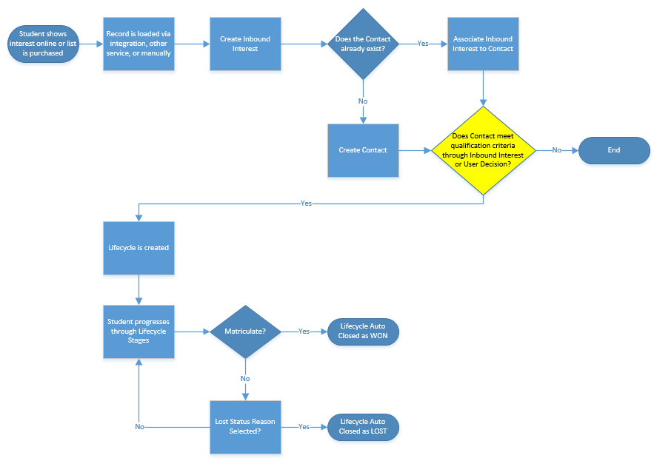



## Client Question

1. What situations should a Lifecycle be created based on the data that is in an Inbound Interest?
2. CONTACT TYPES

## Description

Assigning a Contact a primary “type” in the system allows for segregating data. Contact Types can be added or removed if there is good reason to change them.

Currently, the Contact Types provided are:

1. Student
2. Staff
3. Faculty
4. Alumni
5. Parent
6. Sibling
7. Friend
8. Guest
9. Account
10. Organization Contact



## Client Question

1. Are there additional Contact Types to be added?
2. LIFECYCLE STAGES / BUSINESS PROCESS FLOW

## Description

1. You can help ensure that users enter data consistently and follow the same steps every time they work with a Contact through a business process flow.
2. Once a Contact is “Qualified”, a Lifecycle will manage the stages of their admission
3. Stages of the Contact will be handled by the Stage of the Lifecycle.
4. Logic exists to only allow certain Status Reasons to be selected based on the Stage of the Lifecycle.

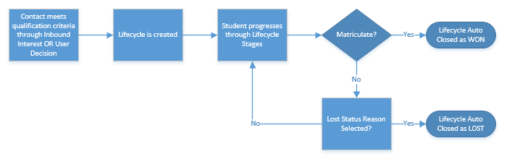

**Status Filter**

|  |  |
| --- | --- |
| Lifecycle Status | Lifecycle Status Reason |
| Lost | Not Eligible |
| Lost | Not Interested |
| Lost | Cancelled |
| Open | Incomplete Application |
| Open | Admitted with Conditions |
| Open | App Requirements Pending |
| Open | Deposit Pending |
| Open | Expressed Interest (Default) |
| Open | Pending Review |
| Open | Ready for Decision |
| Won | Matriculate |

**Status Reason Filter**

|  |  |
| --- | --- |
| BPF Stage | Lifecycle ALLOWED Status Reason |
| Prospect | Expressed Interest (Default) |
| Prospect | Not Eligible |
| Prospect | Not Interested |
| App in Progress | Incomplete Application |
| App in Progress | Cancelled |
| App Complete | Pending Review |
| App Complete | App Requirements Pending |
| App Complete | Ready for Decision |
| App Complete | Cancelled |
| Admit | Admitted with Conditions |
| Admit | Cancelled |
| Deposit | Deposit Pending |
| Deposit | Cancelled |
| Matriculate | Matriculate |

**Lifecycle Stages Out of the Box Layout**

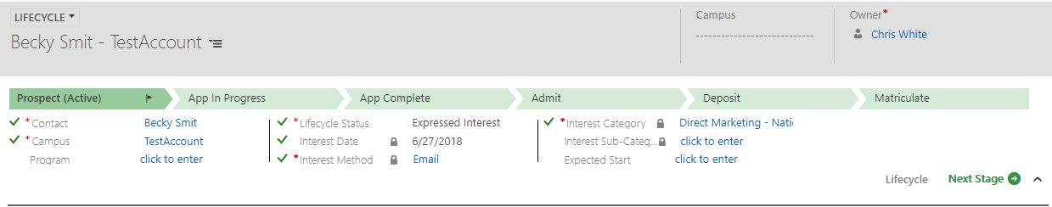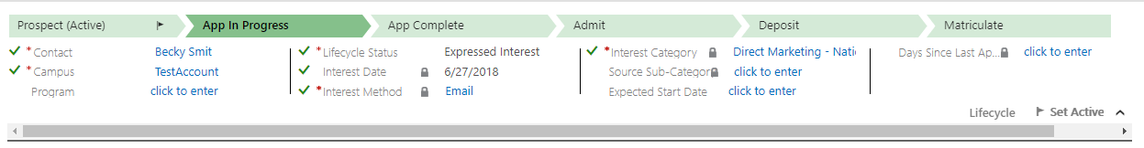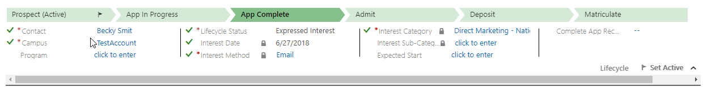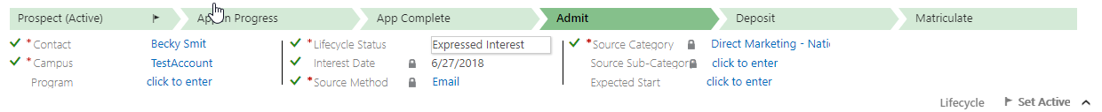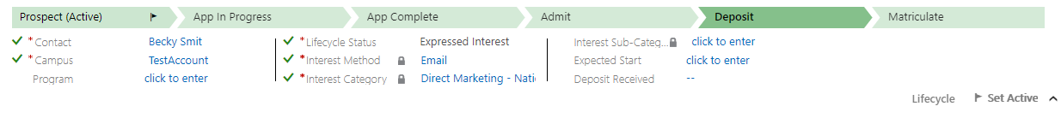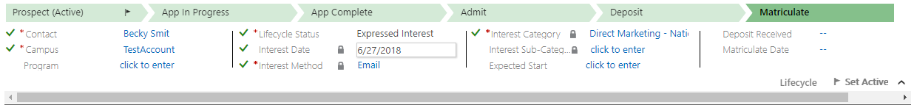



## Client Question

1. Are there any changes that need to be made to the out of the box stages?
2. Are there any changes that need to be made to the fields within each stage? (limit of 15 fields per stage)
3. Should the Lifecycle Status options be changed?
4. DUPLICATE DETECTION RULES

## Description

Duplicate detection rules are used to catch duplicates before they are created. Up to 5 duplicate rules are allowed for each entity.

The duplicate rules out of the box are:

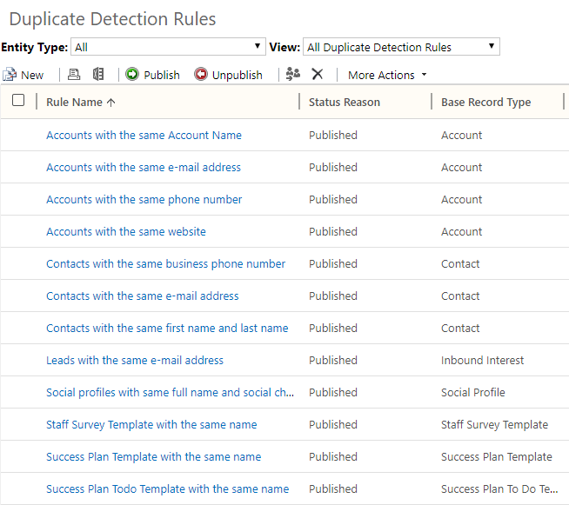



## Client Question

1. Are there any duplicate detection rules you would like to add?
2. Are there any duplicate detection rules you would like to remove?
3. REPORTS

## Description

<https://docs.microsoft.com/en-us/dynamics365/customer-engagement/analytics/reporting-analytics-with-dynamics-365>

Dynamics 365 includes reports, dashboards, and support for Power BI for Office 365 that provides useful business information and visualizations to the user.

**Paginated reports**

Dynamics 365 includes a Report Wizard that can be used to easily create reports in just a few steps without using XML or SQL-based queries. For more information about the Report Wizard, see [Create, edit, or copy a report using the Report Wizard](https://docs.microsoft.com/en-us/dynamics365/customer-engagement/basics/create-edit-copy-report-wizard).

However, to create more complex reports, you can either create your own custom reports from scratch, or use an existing Dynamics 365 report as a template. The topics in this guide show you how to create new reports or change existing reports using Visual Studio as the report writing tool and SQL Server Reporting Services as the report engine.

**Dashboards**

There are two types of dashboards in Dynamics 365—user dashboards and system dashboards. Any user can create a dashboard visible only to them in their work area, such as Sales, Service, or Marketing. An administrator or customizer creates or customizes system dashboards that, when published, are visible to everyone in the organization. A user can choose to set their user dashboard as their default dashboard and override the system dashboard. More information: [Create or customize dashboards](https://docs.microsoft.com/en-us/dynamics365/customer-engagement/customize/create-edit-dashboards)

**Power BI**

Power BI is a self-service business intelligence (BI) platform used to discover, analyze, visualize data, and share or collaborate these insights with colleagues. Power BI provides information workers and everyday business users with excellent data analysis and visualization capabilities to get better business insights. More information: [Use Power BI with Dynamics 365](https://docs.microsoft.com/en-us/dynamics365/customer-engagement/admin/use-power-bi)

There are several ways you can use Power BI with Dynamics 365:

* Load a Dynamics 365 content pack and start using the Power BI service to display Dynamics 365 insights.
* Customize a Dynamics 365 content pack. More information: [Customize Dynamics 365 Power BI content packs](https://docs.microsoft.com/en-us/dynamics365/customer-engagement/analytics/customize-power-bi-content-packs)
* Use Power BI Desktop to modify and customize your reports and visualizations.
* Embed a Power BI tile in a Dynamics 365 personal dashboard.
* Use Power BI and Microsoft Office Excel together.



## Client Question

1. What custom reports are needed? Please provide an example of each report.
2. What is the branding, including the logo, page footer, font, font size and colors, should be used on the reports?
3. DEFAULT DATA

## Description

Default data is provided as a starting point for entities that house general information. For example, there is a State entity that holds all 50 of the United States.



## Client Question

1. Review each of the following entities with default data within Dynamics CRM and update the system with appropriate data. This should be done directly in Dynamics CRM.

|  |
| --- |
| Entity List |
| Address Type |
| Area of Interest |
| Area of Study |
| Completed Verification |
| Configuration |
| Country |
| Education Level |
| Ethnic Group |
| Extra Curricular |
| Language Value |
| Nationality |
| Port of entry |
| Program |
| Program Level |
| Program Version |
| Queue |
| Registration Status |
| School Status |
| Score Definition |
| Scoring Factor |
| Source Category |
| Source Sub-Category |
| Source Category / Source Sub-Category (N:N Relationship) |
| Source Method |
| State |
| Student Classification |
| Student Program Type |
| Student Type |
| Subject |
| Team |
| Theme |
| Title |
| To Do Category |
| US Government Agency |

1. SUBJECTS

## Description

Subjects are used for categorizing Cases. The application comes with the following Subjects:

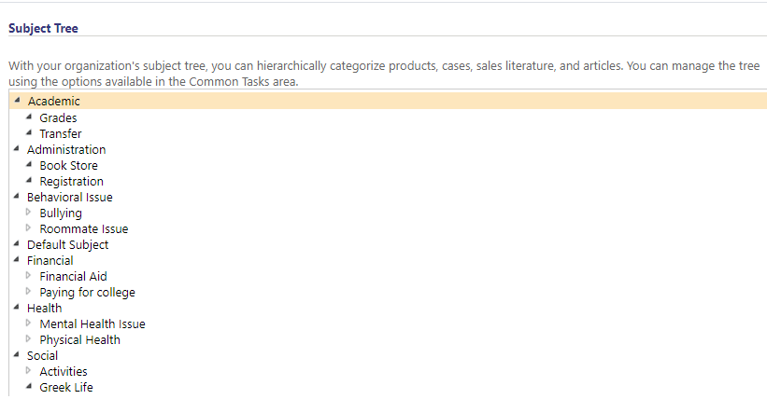



## Client Question

1. What is the Subject Hierarchy for your Organization INCLUDING the out of the box Subjects?
2. QUEUES & TEAMS

## Description

**Queues**

Use queues to organize, prioritize, and monitor the progress of your work. In Dynamics 365, queues are containers used to store anything that needs to be completed or requires an action, for example completing a task or closing a case.

<https://docs.microsoft.com/en-us/dynamics365/customer-engagement/customer-service/set-up-queues-manage-activities-cases>

**Teams**

Using teams in Dynamics 365 is optional. However, teams provide an easy way to share business objects and let you collaborate with other people across business units. While a team belongs to one business unit, it can include users from other business units. You can associate a user with more than one team.

You can use two types of teams:

* An owner team owns records and has security roles assigned to the team. The team’s privileges are defined by these security roles. In addition to privileges provided by the team, team members have the privileges defined by their individual security roles and by the roles from other teams in which they are members. A team has full access rights on the records that the team owns.
* An access team doesn’t own records and doesn’t have security roles assigned to the team. The team members have privileges defined by their individual security roles and by roles from the teams in which they are members. The records are shared with an access team and the team is granted access rights on the records, such as Read, Write, or Append.

<https://docs.microsoft.com/en-us/dynamics365/customer-engagement/admin/manage-teams>



## Client Question

1. Will there be any team ownership of records?
2. What queues will be used to manage the case flow?
3. CONNECTION TYPES

## Description

Connections are used to show how records, including Contacts, are related to each other. The “Connection Role” identifies the type of relationship. There are special Connection Roles that have a Connection Role Category of “Internal” that are especially important and are surfaced on the Contact form in a visual representation.

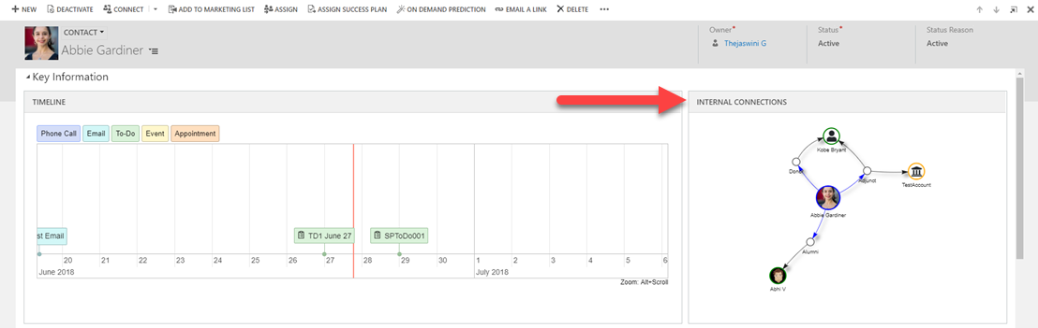

Out of the box Connection Roles (Especially note the Internal Connection Roles)

|  |  |
| --- | --- |
| Connection Role | Connection Role Category |
| Former Employee | Business |
| Employer | Business |
| Former Employer | Business |
| Referral | Business |
| Employee | Business |
| Referred by | Business |
| Child | Family |
| Spouse/Partner | Family |
| Parent | Family |
| Student Worker | Internal |
| Volunteer Alumni | Internal |
| Donor | Internal |
| Matching Donor | Internal |
| Faculty | Internal |
| Adjunct | Internal |
| UG Prospect | Internal |
| Graduate Prospect | Internal |
| Staff | Internal |
| Alumni | Internal |
| Undergraduate Student | Internal |
| Graduate Student | Internal |
| Friend | Social |



## Client Question

1. What connection roles are not desired?
2. Are there any additional connection roles to be added?
3. INBOUND INTEREST SOURCES

## Description

For a potential student, this feature helps to keep track of the initial source and any additional inbound interest records so that these sources can be tapped in future recruitment cycles with a view to optimally manage student admissions.

After collating and analysing data of historical student recruitment patterns, an institution can make decisions about optimizing their recruitment by targeting or ignoring specific media or aggressively promoting specific programs.

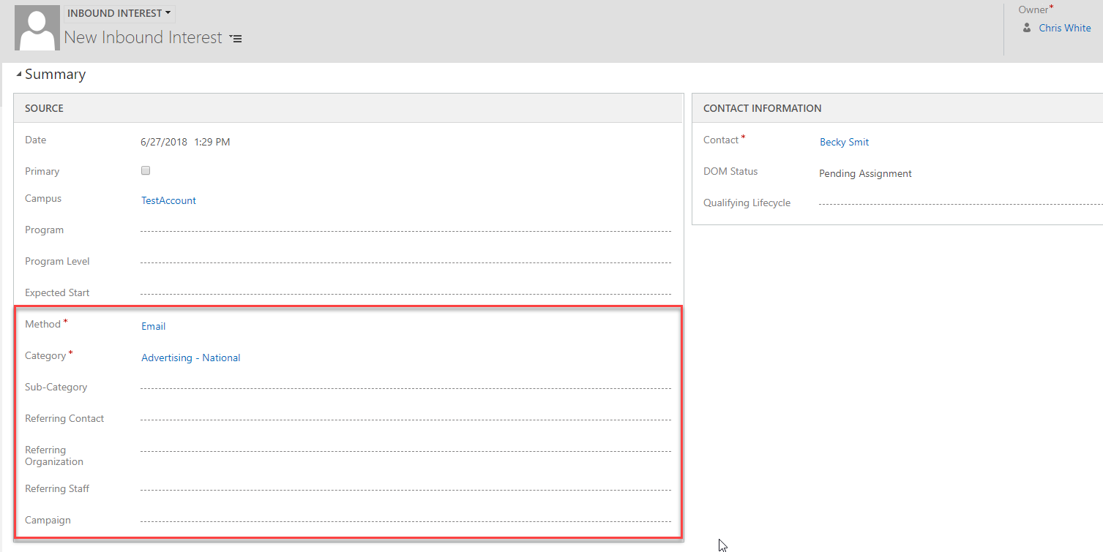

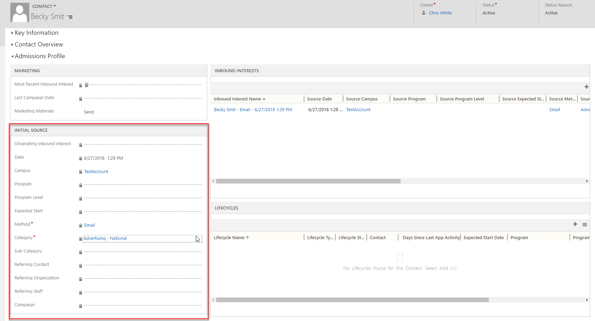

Out of the box Source Data:

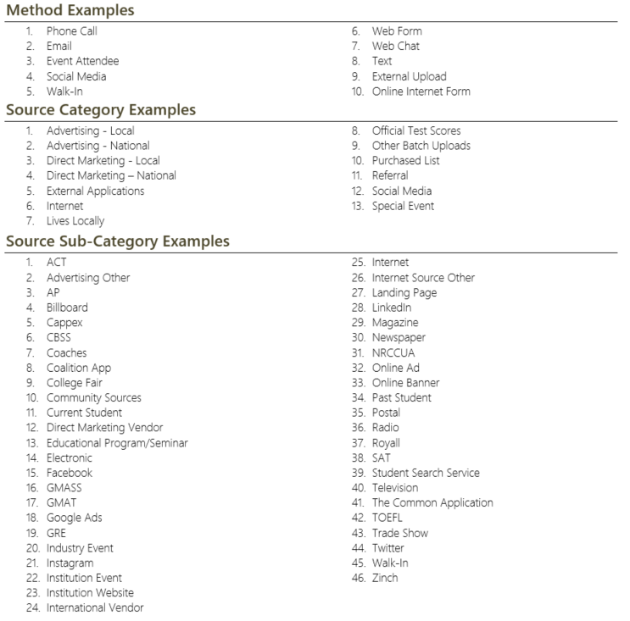



## Client Question

1. Are there any changes that need to be made to the Source tracking data?
2. CONTACT RETENTION SCORING RULES

## Description

This feature provides the ability to assign a retention score for each student, cohort/student group OR all students so that campuses can review individual student's OR a group's performance.

Example Data

Factor Group

1. Name: Freshman Engineers

Factor Filters (selection of the group of Students)

1. Attribute Name: Type

Value: Freshman

1. Attribute Name: Program

Value: Engineer

Factor Score

1. Entity Name: Student

Attribute Name: Age

Type: Range

Min: 18

Max: 20

Points: 40

1. Entity Name: Student

Attribute Name: Age

Type: Range

Min: 21

Max: 23

Points: 30

1. Entity Name: Student

Attribute Name: Gender

Type: Value

Value: Male

Points: 30

1. Entity Name: Student

Attribute Name: Gender

Type: Value

Value: Female

Points: 20



Default Data:

|  |  |  |  |
| --- | --- | --- | --- |
| **Factor** | **Options** | **Points** | **Comments** |
| Residence | Dorm | 57 |  |
| Non-Dorm | 36 |
| Null | 36 |
| Gender | Male | 50 |  |
| Female | 50 |
| Null | 50 |
| ACT | 0-11 | 17 | # Only the composite scores will be considered for the computation. # If multiple ACT scores are available, the one with the highest composite score will be considered |
| 12-14 | 26 |
| 14-17 | 42 |
| 18-23 | 54 |
| 24-29 | 65 |
| 30-36 | 75 |
| Null | 50 |
| SAT | 400-500 | 14 | # Only the composite scores will be considered for the computation. # If multiple SAT scores are available, the one with the highest composite score will be considered |
| 501-700 | 20 |
| 701-900 | 37 |
| 901-1100 | 50 |
| 1101-1300 | 56 |
| 1301-1600 | 67 |
| Null | 21 |
| Attendance status | Part Time | 43 |  |
| Full Time | 57 |
| Null | 43 |
| High school graduating percentile rank | 90-99 | 65 | # If multiple high schools are associated with the same student, choose the one with a graduation date. |
| 75-89 | 55 |
| 50-74 | 45 |
| 25-49 | 40 |
| 1-24 | 28 |
| Null | 28 |
| Age | 16-18 | 56 |  |
| 19 | 45 |
| 20-21 | 40 |
| 22-25 | 49 |
| 26-29 | 61 |
| 30-34 | 41 |
| 35-39 | 36 |
| 40-99 | 58 |
| Null | 50 |
| Miles from Home | 0-10 | 50 |  |
| 10-75 | 45 |
| 75-150 | 40 |
| 150 + | 35 |
| Null | 35 |
| Mid Term Deficiencies | Yes | 35 |  |
| No | 55 |
| Null | 55 |
| Total EFC | 0-1000 | 40 |  |
| 1001-2000 | 43 |
| 2001-3000 | 35 |
| 3001-+ | 50 |
| Null | 45 |
| First Generation | Yes | 0 |  |
| No | 75 |
| Null | 25 |



## Client Question

1. What are the metrics for retention scoring for your organization?
2. What needs to be updated in the default data regarding scoring?
3. SETUP SUCCESS PLAN ASSIGNMENT RULES

## Description

The system has the ability to automatically assign students Success Plans. These are configurable based on custom criteria.

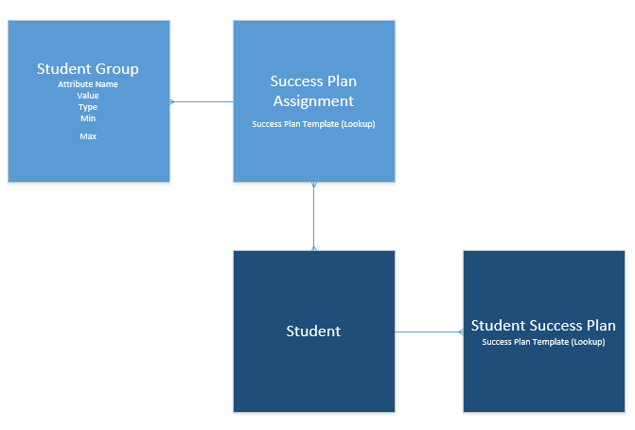



## Client Question

1. How do you group students for success planning?
2. Are there any specific one-off groups created based on a special use case?